GURU NANAK DEV ENGINEERING COLLEGE
DEPARTMENT OF
INFORMATION TECHNOLOGY

PRACTICAL FILE
Advanced Web Technologies
(5th Semester 2021-2025 Batch)
JULY-DECEMBER,2023


Submitted to: Submitted by:
(Prof).Akshay Girdhar Jasmeen Kaur Gill
URN:2104390
CRN:2121138

INDEX
S. NO. | EXPERIMENT | PAGE NO. | SIGNATURE
1
  To install and setup the HTML5 based Bootstrap framework and to deploy basic HTML elements using Bootstr̥ap CSS.
2 | To understand and deploy the multicolumn grid layout of Bootstrap.
3 | To deploy different types of buttons, progress bars, modals and navigation bars using Bootstrap.
4 | To create and setup the Git repository on Bitbucket or github using SSH.
5 | To perform push, clone and patch operation to Git repository.
6 | To install and setup the CodeIgniter Framework and to understand its MVC architecture.
7 | To construct a simple login page web application to authenticate users using CodeIgniter Framework and also perform CURD operations.
8 | To install and setup, configure the Laravel Framework.
9 | To construct the any simple web application using Laravel Framework.
10 | Minor Project: Attendance Management System in CodeIgniter

EXPERIMENT NO. 01: Install and setup the HTML5 based Bootstrap framework and to deploy basic HTML elements using Bootstrap CSS.

Bootstrap 5 is a popular front-end framework created by Twitter for building responsive and visually appealing web applications. Some are enlisted below:
- Responsive Design: Ensures that webpage functions well on various devices and screen sizes.
- Modular and Reusable Components: Provide wide range of pre-designed UI components i.e. navigation bars, buttons, forms, cards etc.
- Utility Classes: Introduced classes can help with tasks like spacing, alignment, typography etc reducing the need for custom CSS.
- Sass Support: It is built with Sass, powerful CSS preprocessor, which makes it easier to customize the framework to match webpage’s specific design requirements.
- Improved Documentation: Documentation has been updated and enhanced.
- Customizable Themes: It allows creating and customizing themes easily using the Bootstrap CLI or online theme builders.
- Community and Support: It has large and active community i.e. can find plenty of resources, plugins and third-party extensions to extend the functionality.
Different ways to install Bootstrap 5 are enlisted below:
- Use bootstrap 5 via CDN links
In below code there are two bootstap links added
For CSS: https://cdn.jsdelivr.net/npm/bootstrap@5.3.1/dist/css/bootstrap.min.css
For JS: https://cdn.jsdelivr.net/npm/bootstrap@5.3.1/dist/js/bootstrap.bundle.min.js

CODE:
<!DOCTYPE html>
<html>
<head>
<meta charset="utf-8">
<meta name="viewport" content="width=device-width, initial-scale=1">
<title>jasmeen kaur gill</title>
<link href="https://cdn.jsdelivr.net/npm/bootstrap@5.3.1/dist/css/bootstrap.min.css" rel="stylesheet" integrity="sha384-4bw+/aepP/YC94hEpVNVgiZdgIC5+VKNBQNGCHeKRQN+PtmoHDEXuppvnDJzQIu9" crossorigin="anonymous">
</head>
<body>
<h1>Welcome</h1>
<p>Lorem ipsum dolor sit amet, consectetur adipisicing elit, sed do
eiusmod tempor incididunt ut labore et dolore magna aliqua.</p>
<script src="https://cdn.jsdelivr.net/npm/bootstrap@5.3.1/dist/js/bootstrap.bundle.min.js" integrity="sha384-HwwvtgBNo3bZJJLYd8oVXjrBZt8cqVSpeBNS5n7C8IVInixGAoxmnlMuBnhbgrkm" crossorigin="anonymous"></script>
</body>
</html>

OUTPUT:
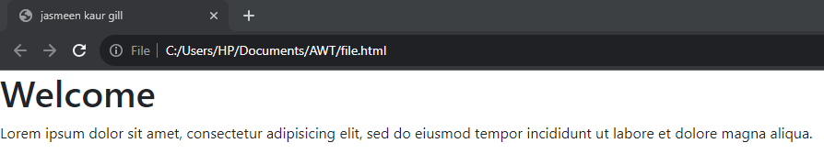
- Download Compiled CSS and JS
STEP 1: Go to this link to and click on download under Compiled CSS and JS https://getbootstrap.com/docs/5.3/getting-started/download/.
STEP 2: It will download following zip file consisting of two folders. Then extract it.

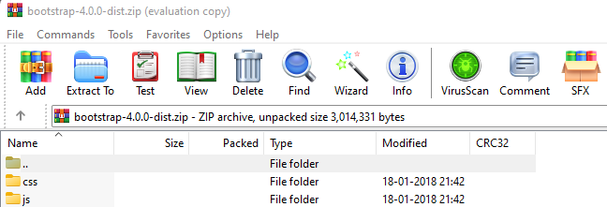

CSS folder consists of below files. We can import file whose functionalities we need in our code.

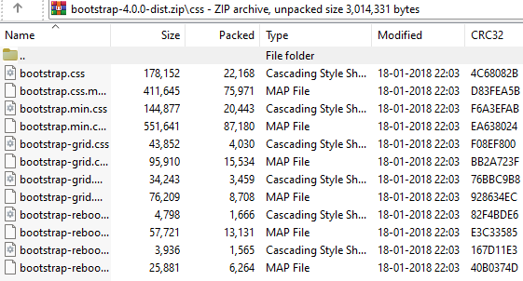

JS folder consists of below files. We can import file whose functionalities we need in our code.

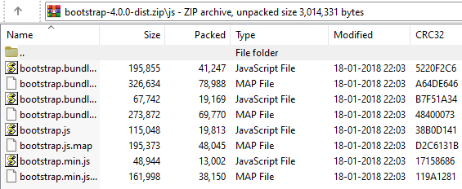
Here bootstrap.min.css and bootstrap.min.js are the files which contain css and js code in minified form i.e without spaces in code. This is difficult to understand but is used when working on large real time project in order to make project light in memory.

CODE:
<!DOCTYPE html>
<html>
<head>
<meta charset="utf-8">
<meta name="viewport" content="width=device-width, initial-scale=1">
<title>jasmeen kaur gill</title>
<link href="css/bootstrap.css" rel="stylesheet">
</head>
<body>
<h1>Welcome</h1>
<p>Lorem ipsum dolor sit amet, consectetur adipisicing elit, sed do
eiusmod tempor incididunt ut labore et dolore magna aliqua.</p>
<div class="container">
<div class="row">
<div class="col-3">
Content for the 1st column
</div>
<div class="col-3">
Content for the 2nd column
</div>
<div class="col-3">
Content for the 3rd column
</div>
<div class="col-3">
Content for the 4th column
</div>
</div>
</div>
<script src="js/bootstrap.js" ></script>
</body>
</html>
In above code using combined CSS and JS, I have imported two bootstrap 5 files one for css named css/bootstrap.css and another named js/bootstrap.js to provide responsiveness to the webpage.
OUTPUT:
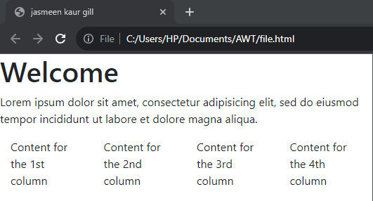
Basic bootstrap 5 code to showcase “container class”, “grid class” and “breakpoints”
Breakpoint | Class infix | Dimensions
X-Small | None | <576px
Small | sm | ≥576px
Medium | md | ≥768px
Large | lg | ≥992px
Extra large | xl | ≥1200px
Extra extra large | xxl | ≥1400px
Breakpoints Table
CODE:
<!DOCTYPE html>
<html lang="en">
<head>
<meta charset="UTF-8">
<meta name="viewport" content="width=device-width, initial-scale=1">
<title>jasmeen kaur gill</title>
<link href="css/bootstrap.css" rel="stylesheet">
</head>
<body>
<div class="container">
<h1 class="mt-5">Hi! Welcome to learn BOOTSTRAP 5</h1>
<p>Basic bootstrap 5 code to showcase “container class”, “grid class” and “breakpoints”
</p>

<div class="row">
<div class="col-lg-4">
<div class="bg-primary p-3 text-white">
<p>Col 1 (Larger Screens & above)</p>
</div>
</div>
<div class="col-lg-4">
<div class="bg-success p-3 text-white">
<p>Col 2 (Larger Screens & above)</p>
</div>
</div>
<div class="col-lg-4">
<div class="bg-warning p-3 text-dark">
<p>Col 3 (Larger Screens & above)</p>
</div>
</div>
</div>

<div class="row">
<div class="col-sm-6 col-md-3">
<div class="bg-info p-3 text-white">
<p>Col 1 (Small and Medium)</p>
</div>
</div>
<div class="col-sm-6 col-md-3">
<div class="bg-danger p-3 text-white">
<p>Col 2 (Small and Medium)</p>
</div>
</div>
<div class="col-sm-6 col-md-3">
<div class="bg-secondary p-3 text-white">
<p>Col 3 (Small and Medium)</p>
</div>
</div>
<div class="col-sm-6 col-md-3">
<div class="bg-info p-3 text-white">
<p>Col 4 (Small and Medium)</p>
</div>
</div>
</div>
</div>
<script src="js/bootstrap.js" ></script>
</html>

OUTPUT:
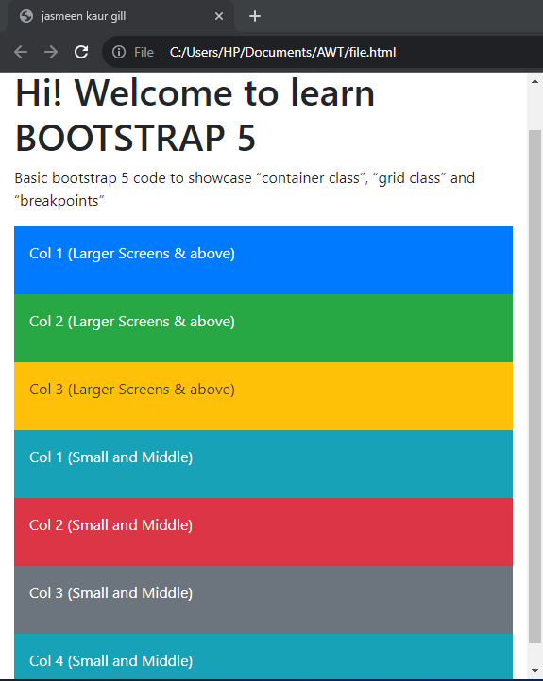
For X-SMALL, SMALL
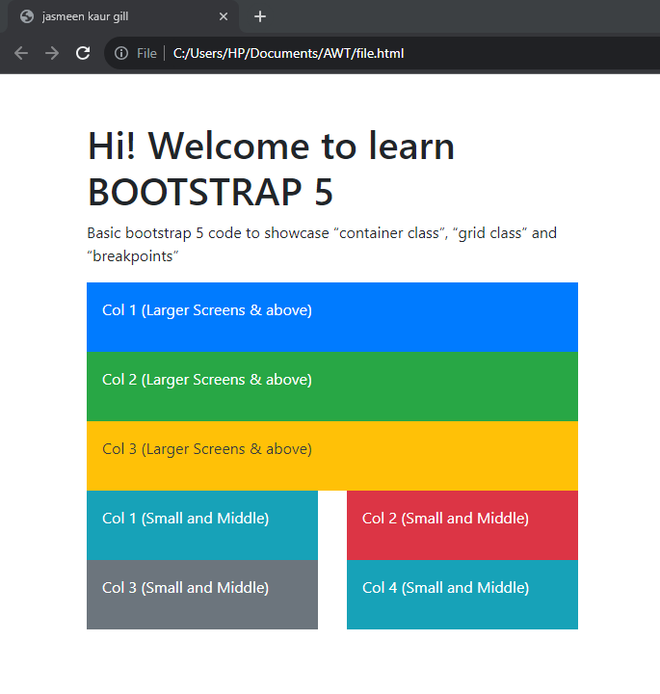
For MEDIUM
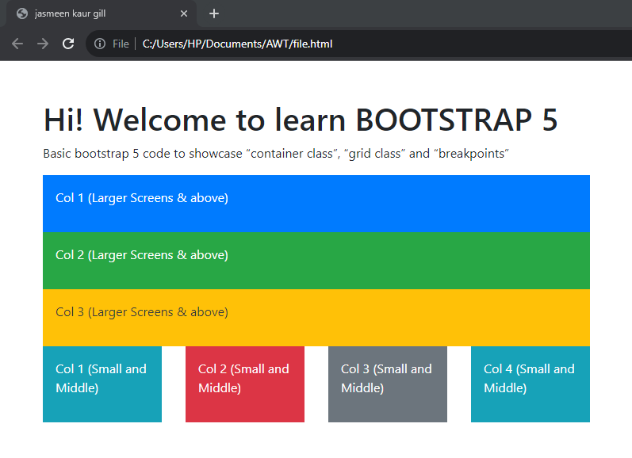
For MEDIUM
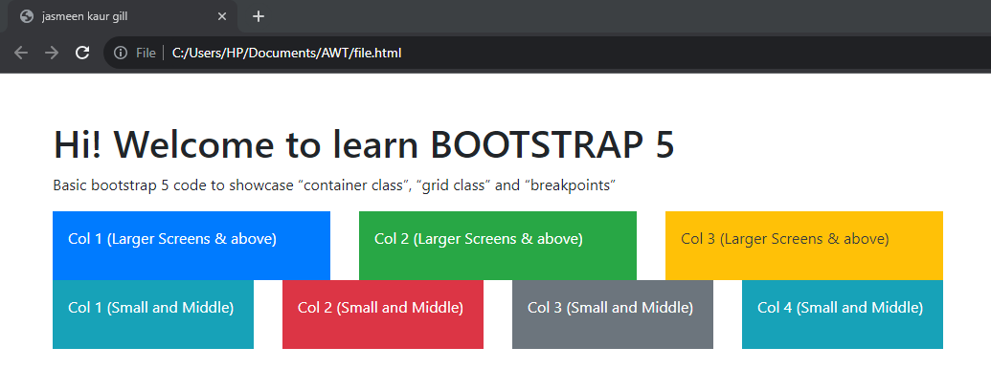
For LARGE, EXTRA LARGE and EXTRA EXTRA LARGE
Code of simple website using text colours, background colours, form and table
CODE:
<!DOCTYPE html>
<html lang="en">
<head>
<meta charset="UTF-8">
<meta name="viewport" content="width=device-width, initial-scale=1.0">
<title>jasmeen kaur gill</title>
<link href="css/bootstrap.css" rel="stylesheet">
</head>
<body>
<div class="container-fluid bg-dark">
<div class="container">
<h1 class="text-white">Bootstrap 5 Website</h1>
<p class="text-white">This is a basic webpage with a form and a table.</p>

<!-- Form Section -->
<div class="row">
<div class="col-lg-12">
<div class="bg-primary p-3 text-center text-warning">
<form>
<h2>FORM</h2>
<div class="mb-3">
<label for="name" class="form-label">Name</label>
<input type="text" class="form-control" id="name" placeholder="Your Name">
</div>
<div class="mb-3">
<label for="email" class="form-label">Email</label>
<input type="email" class="form-control" id="email" placeholder="Your Email">
</div>
<div class="mb-3">
<label for="message" class="form-label">Message</label>
<textarea class="form-control" id="message" rows="4" placeholder="Your Message">
</textarea>
</form>
</div>
</div>
</div>
</div>
<!-- Table Section -->
<div class="container mt-5"></div>
<h2 class="text-white">D3 IT Subjects</h2>
<div class="row">
<div class="col-lg-12">
<div class="bg-success p-3 text-white">
<table class="table table-bordered">
<thead>
<tr>
<th>S.No.</th>
<th>Subject Name</th>
<th>Subject Teacher</th>
</tr>
</thead>
<tbody>
<tr>
<td>1</td>
<td>Advance Web Technology</td>
<td>Dr. Akshay Girdhar</td>
</tr>
<tr>
<td>2</td>
<td>Theory of Computation</td>
<td>Prof. Rupinder Kaur</td>
</tr>
<tr>
<td>3</td>
<td>Java</td>
<td>Prof. Gitanjli</td>
</tr>
<tr>
<td>4</td>
<td>Discrete Mathematics</td>
<td>Prof. Jaskiran Kaur</td>
</tr>
<tr>
<td>5</td>
<td>Internet of Things</td>
<td>Prof. Himani</td>
</tr>
</tbody>
</table>
</div>
</div>
</div>
</div>
</div>
<script src="js/bootstrap.js" ></script>
</body>
</html>

OUTPUT:
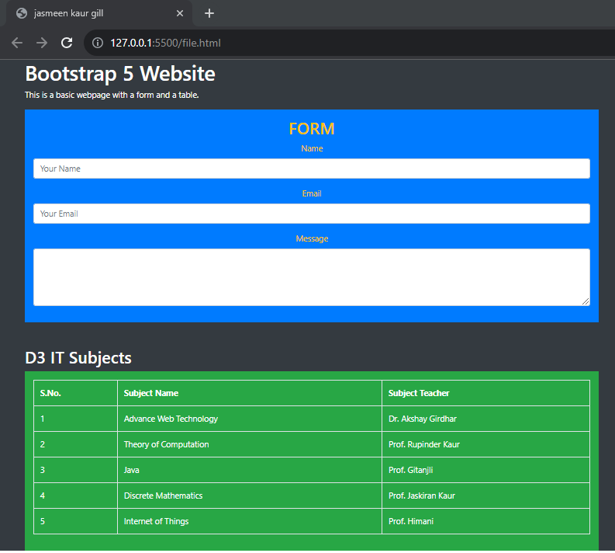

EXPERIMENT NO. 02: To understand and deploy the multicolumn grid layout of Bootstrap.
CODE:

1.html
<!DOCTYPE html>
<html lang="en">
<head>
<meta charset="UTF-8">
<meta name="viewport" content="width=device-width, initial-scale=1.0">
<title>jasmeen kaur gill</title>
<link href="css/bootstrap.css" rel="stylesheet">
<link rel="stylesheet" href="style2.css">
</head>
<body>
<div class="container">
<div class="row">
<div class="col-12" id="header">
<h1>WEBSITE NAME</h1>
</div>
</div>
<div class="row">
<div class="col-12" id="nav">
<ul>
<li><a href="">HOME </a></li>
<li><a href="">ABOUT US</a></li>
<li><a href="">PRODUCT</a></li>
<li><a href="">GALLARY</a></li>
<li><a href="">CONTACT US</a></li>
</ul>
</div>
</div>
<div class="row">
<div class="col-md-12 col-lg-8" id="sub">
<h2>SUB HEADING</h2>
<p>Lorem ipsum dolor sit, amet consectetur adipisicing elit. Fugiat eum ea optio neque omnis, fugit, illum unde aliquam sapiente autem nobis, recusandae dignissimos dolor ut dolorem dicta veritatis cupiditate deleniti.</p>
</div>
<div class="col-lg-4 col-md-12" id="side">
<center>
<h5>AD 01</h5>
<h5>AD 02</h5>
<h5>AD 03</h5>
<h5>AD 04</h5>
<h5>AD 05</h5>
</center>
</div>
</div>
<div class="row" id="foot">
<div class="col-12">
<h3>FOOTER</h3>
</div>
</div>
</div>
</body>
</html>

style2.css
.container {
border: 3px solid white;
}
.row {
border: 3px solid black;
}
.col-1,.col-2,.col-3,.col-4,.col-5,.col-6,.col-7,.col-8,.col-9,.col-10,.col-11,.col-12 {
border: 3px solid white;
}
#header{
background-color:red;
}
#nav{
background-color:rgb(108, 18, 108);
}
#sub{
background-color:sandybrown;
}
#side{
background-color:darkkhaki;
}
#foot{
background-color:olive;
}

OUTPUT:
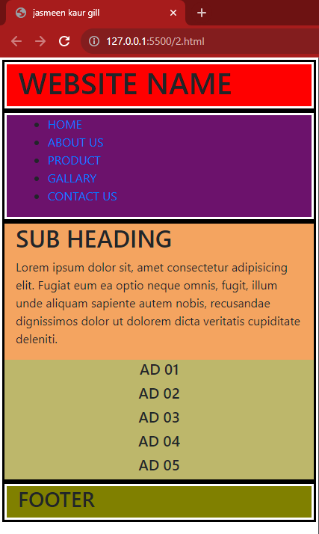
For MEDIUM, SMALL, X-SMALL
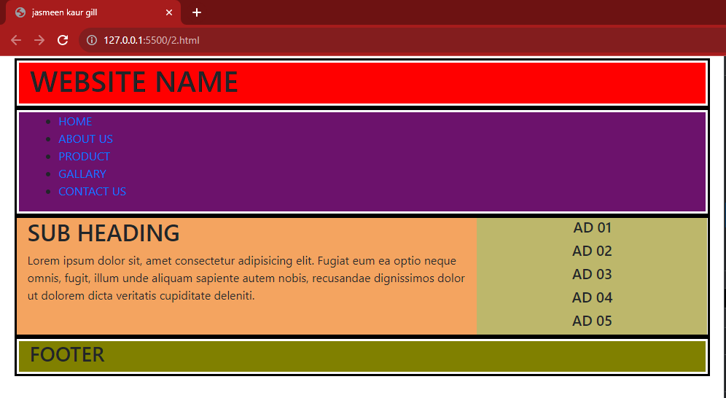
For LARGE, EXTRA LARGE, EXTRA EXTRA LARGE
EXPERIMENT NO. 03: To deploy different types of buttons, progress bars, modals and navigation bars using Bootstrap.
CODE:
<!DOCTYPE html>
<html>
<head>
<meta charset="UTF-8">
<title>Portfolio</title>
<link rel="stylesheet" href="https://maxcdn.bootstrapcdn.com/bootstrap/4.5.2/css/bootstrap.min.css">
<link rel="stylesheet" href="style.css"> <!-- Your custom CSS file -->
</head>
<body>
<!-- Navigation Bar -->
<nav class="navbar navbar-expand-lg navbar-light bg-secondary">
<a class="navbar-brand" href="#">My Portfolio</a>
<button class="navbar-toggler" type="button" data-toggle="collapse" data-target="#navbarNav" aria-controls="navbarNav" aria-expanded="false" aria-label="Toggle navigation">
<span class="navbar-toggler-icon"></span>
</button>
<div class="collapse navbar-collapse" id="navbarNav">
<ul class="navbar-nav ml-auto">
<li class="nav-item">
<a class="nav-link" href="#about">About</a>
</li>
<li class="nav-item">
<a class="nav-link" href="#projects">Projects</a>
</li>
<li class="nav-item">
<a class="nav-link" href="#contact">Contact</a>
</li>
</ul>
</div>
</nav>
<!-- Progress Bar -->
<div class="container mt-4">
<h3>Skills</h3>
<!-- Progress Bars -->
<h6>Presentation</h6>
<div class="progress mb-3">
<div class="progress-bar progress-bar-striped progress-bar-animated" role="progressbar" style="width: 0%;" id="progress-bar-1"></div>
</div>
<h6>Logical</h6>
<div class="progress mb-3">
<div class="progress-bar progress-bar-striped progress-bar-animated" role="progressbar" style="width: 0%;" id="progress-bar-2"></div>
</div>
<h6>Designing</h6>
<div class="progress mb-3">
<div class="progress-bar progress-bar-striped progress-bar-animated" role="progressbar" style="width: 0%;" id="progress-bar-3"></div>
</div>

<!-- Progress Control Buttons -->
<button class="btn btn-secondary mr-4" onclick="updateProgressBar(1, 10)">Presentation</button>
<button class="btn btn-success mr-4" onclick="updateProgressBar(2, 20)">Logic</button>
<button class="btn btn-secondary" onclick="updateProgressBar(3, 30)">Design</button>

<!-- Buttons -->
<div class="container mt-4">
<h3>Certifications</h3>
<button class="btn btn-primary mr-4">Angular</button>
<button class="btn btn-secondary mr-4">React JS</button>
<button class="btn btn-primary">DBMS</button>
</div>

<!-- Button trigger modal -->
<div class="container mt-4">
<h3>This is a long content modal</h3>
<button type="button" class="btn btn-success" data-toggle="modal" data-target="#exampleModalLong">
Launch demo modal
</button>
</div>
<!-- Modal -->
<div class="modal fade" id="exampleModalLong" tabindex="-1" role="dialog" aria-labelledby="exampleModalLongTitle" aria-hidden="true">
<h3>Modal</h3>
<div class="modal-dialog" role="document">
<div class="modal-content">
<div class="modal-header">
<h5 class="modal-title" id="exampleModalLongTitle">Scrolling Long Content</h5>
<button type="button" class="close" data-dismiss="modal" aria-label="Close">
<span aria-hidden="true">&times;</span>
</button>
</div>
<div class="modal-body">
Learning to code is no longer a “speciality” skill. Rather, it has become a mainstream, core discipline utilized in nearly every industry; requiring more and more skilled workers every year.
Coding tests a variety of abilities. It hones problem-solving and analysis skills, such as finding errors and thinking logically. Further, coding often helps people develop teamwork and interpersonal skills since software and application projects are often cross-disciplinary and collaborative.
Perhaps coding’s biggest attraction is that almost anyone can learn it. Aspiring coders don’t necessarily need to be experts in math or have vast prior experience. To get started, they simply need to be inquisitive, committed to learning, and willing to practice their coding skills regularly while learning from their mistakes. This accessibility makes coding a potential path for career switchers and brand-new professionals alike.
Steve Jobs, the late co-founder of Apple, famously said that everyone should learn a computer language because “it teaches you how to think.” Jobs went further, saying that he views computer science as a “liberal art;” one that should be part of every education.
</div>
<div class="modal-footer">
<button type="button" class="btn btn-secondary" data-dismiss="modal">Close</button>
<button type="button" class="btn btn-primary">Save changes</button>
</div>
</div>
</div>
</div>

<!-- Your portfolio content -->

<script src="https://code.jquery.com/jquery-3.5.1.slim.min.js"></script>
<script>
function updateProgressBar(barNumber, incrementBy) {
const progressBar = document.getElementById(`progress-bar-${barNumber}`);
let currentWidth = parseInt(progressBar.style.width, 10) || 0;
currentWidth += incrementBy;

if (currentWidth > 100) {
currentWidth = 100;
}

progressBar.style.width = currentWidth + "%";
}
</script>
<script src="https://cdn.jsdelivr.net/npm/@popperjs/core@2.5.3/dist/umd/popper.min.js"></script>
<script src="https://stackpath.bootstrapcdn.com/bootstrap/4.5.2/js/bootstrap.min.js"></script>
</body>
</html>
Output:
AT lARGE SCREEN SIZE
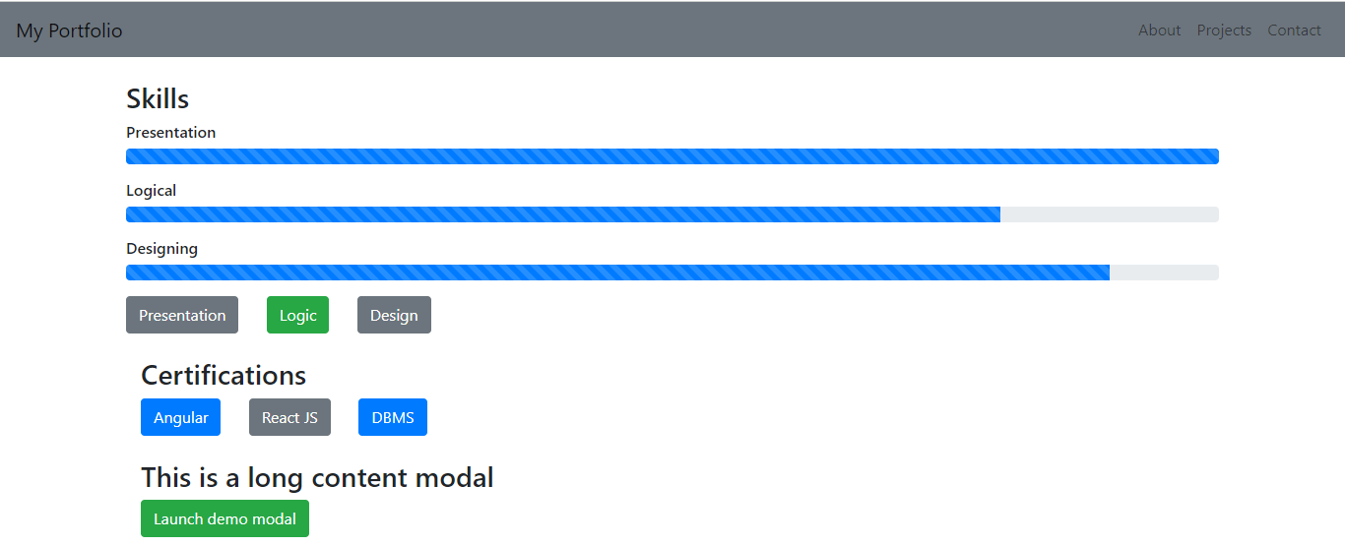

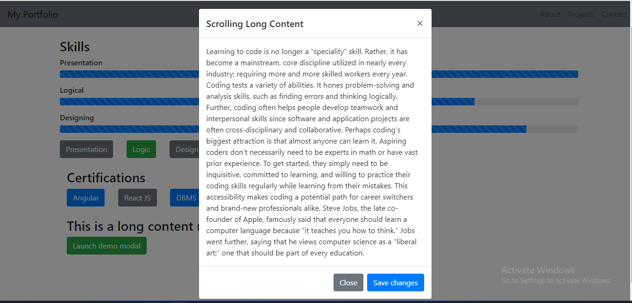

AT MEDIUM SCREEN SIZE
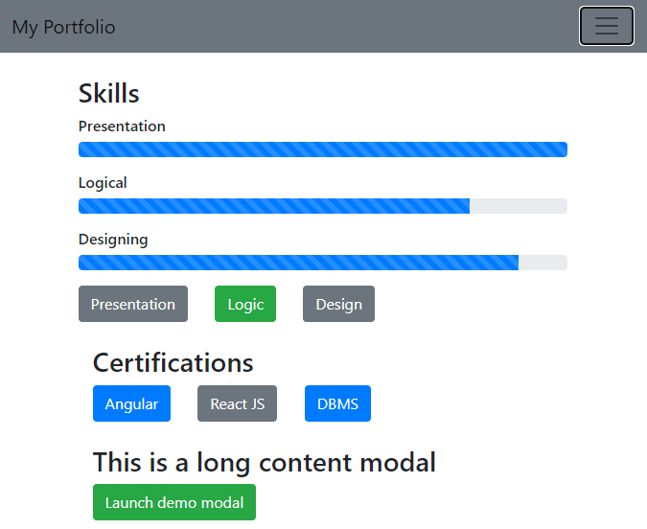
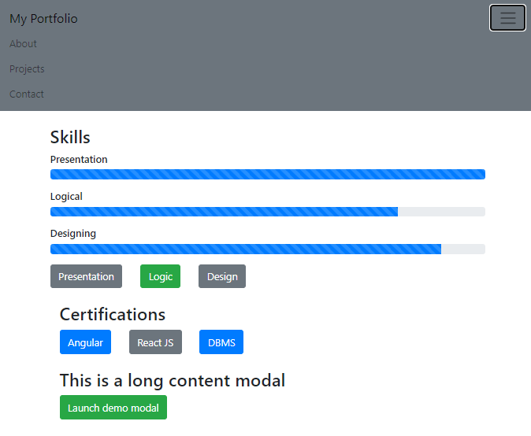

EXPERIMENT NO. 04: To create and setup the Git repository on github using SSH.
Step 1: Install Git
Download and install Git from the official website: https://git-scm.com/download/win
After writing command git this is shown on cmd.
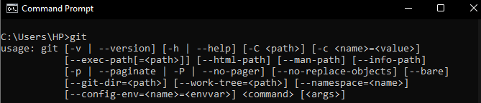
Step 2: Configure Git
Set your Git username and email by running these commands in your terminal:
git config --global user.name "JasmeenGill17"
git config --global user.email “jeenugill017@gmail.com”
Step 3: Generate SSH Key
Generate an SSH key to securely connect to GitHub:
ssh-keygen -t ed25519 -C "jeenugill017@gmail.com "
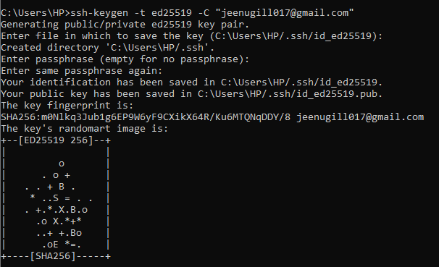
This is the place where SSH Key is generated
C:\Users\HP/.ssh/id_ed25519.pub
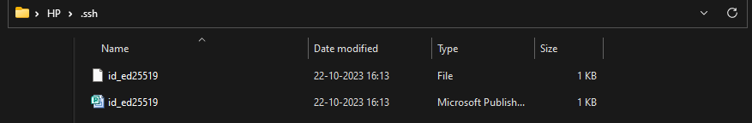
Step 5: Add SSH Key to GitHub
Copy your public SSH key to your clipboard:
cat ~/.ssh/id_ed25519.pub
Go to GitHub account settings, under "SSH and GPG keys," click "New SSH key," and paste public key there.
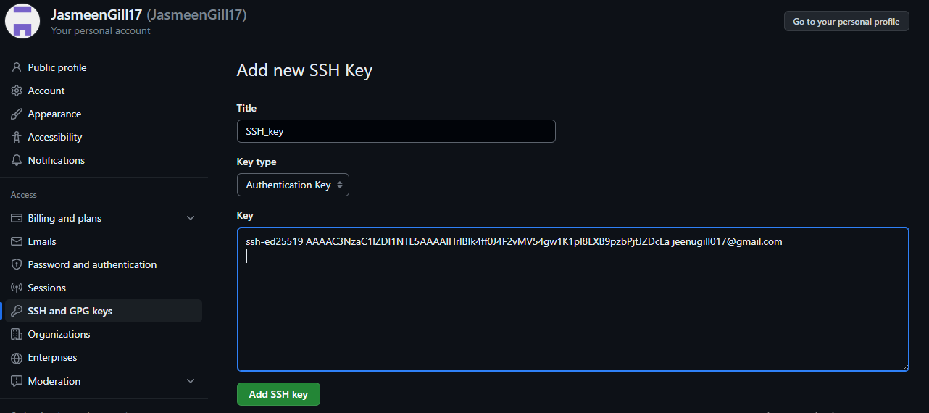
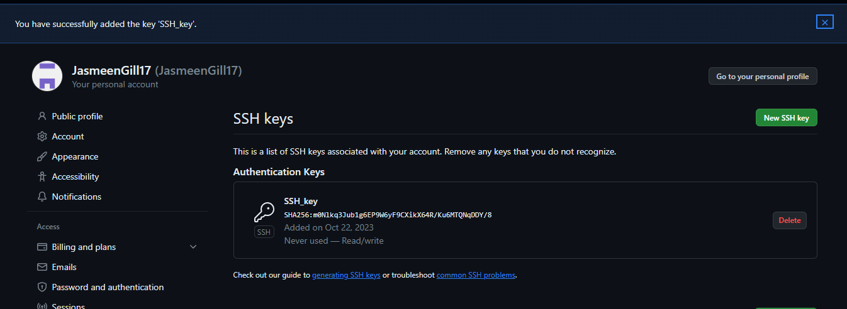
Step 6: Create a New Repository on GitHub
On GitHub, click the "+" icon in the top right corner and select "New repository." Fill in the repository name, description, and other options.
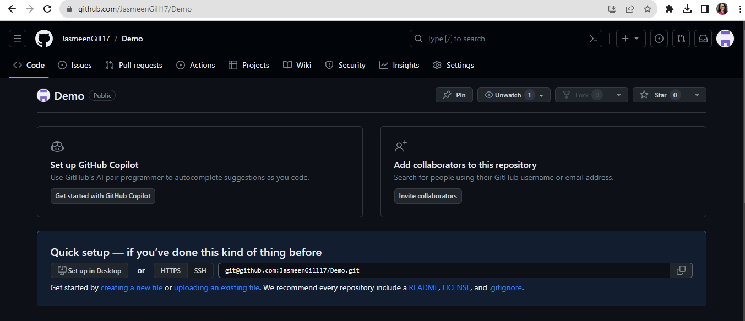
git@github.com:JasmeenGill17/Demo.git
This is the SSH Key link of repository “Demo”.

EXPERIMENT NO. 05: To perform push, c lone and patch operation to Git repository.
Cloning a repository
$ cd D:/GIT_Demo
$ git clone https://github.com/JasmeenGill17/Demo.git
This will clone the remote repository in my local machine.
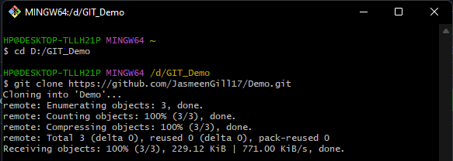
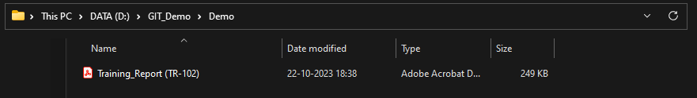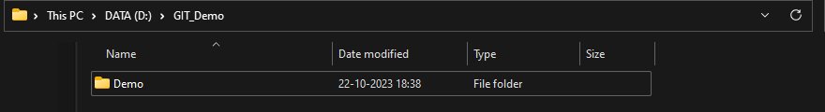

Push changes from local machine to my remote github repository
STEP 1: Now make a new text file in the folder and then push the changes.
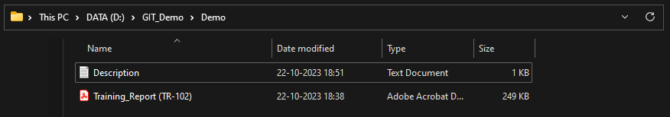
STEP 2: This shows that I have one untracked change

$ git status
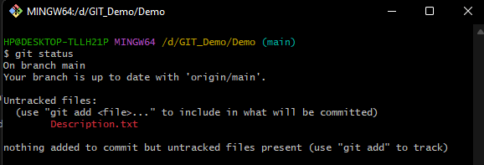
$ git add .
$ git commit –m “Description file added”
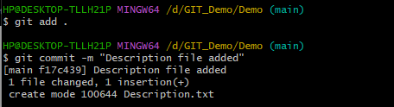
$ git push
It will redirect to a github login page and if passward is correct it will show message as shown below.
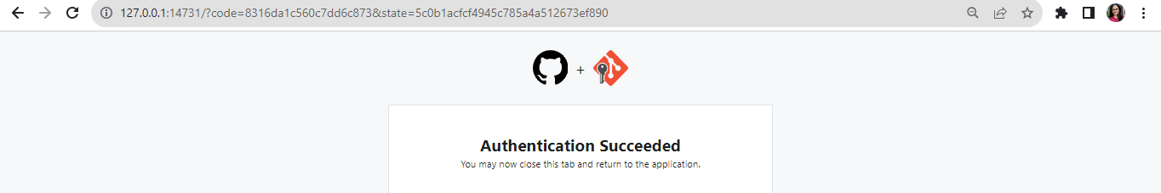
In GIT BASH it will show as below if push is successful.
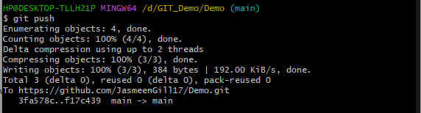

Added Successfully

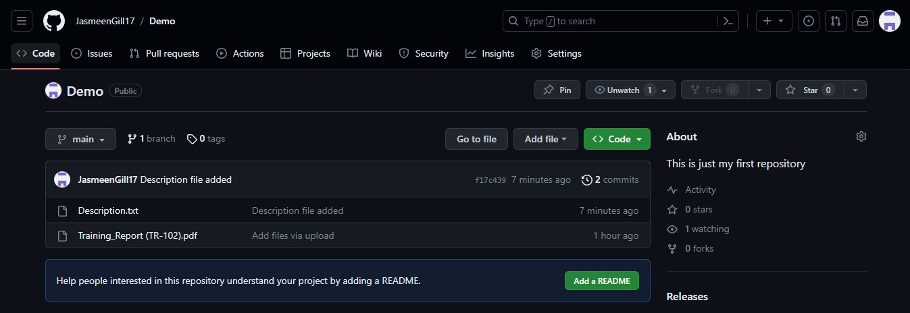
Patch Operation:
Made a change in Description.txt file and applied following command:
$ git status
It shows that changes are not staged.
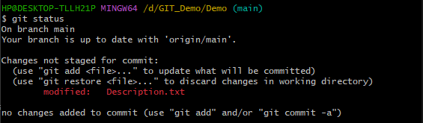
$ git add .
$ git commit –m “Modified the file”
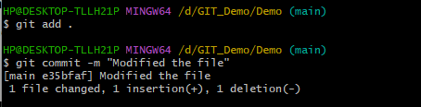
$ git push
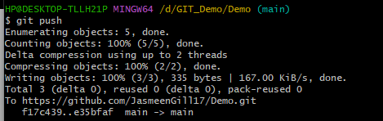
Modifications Done
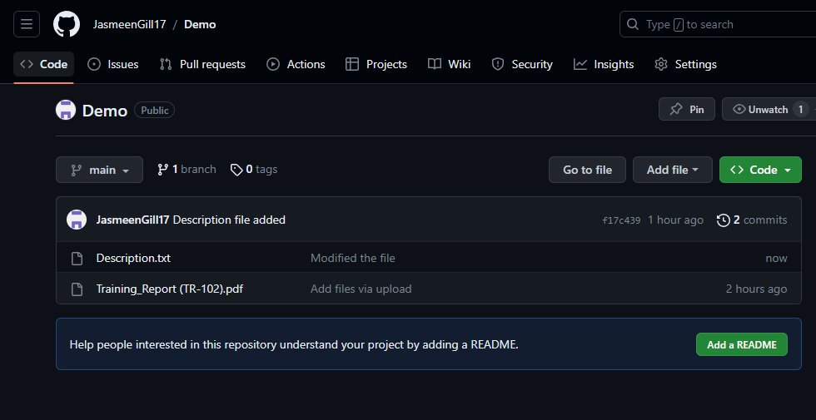
Creating a Patch:
$ git format-patch -1
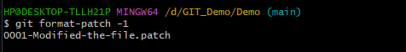
Applying a Patch:
$ git apply 0001-Modified-the-file.patch
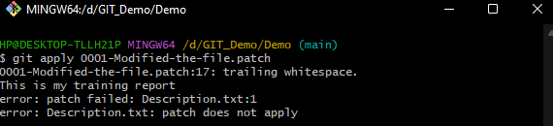
EXPERIMENT NO. 06: To install and setup the CodeIgniter Framework and to understand its MVC architecture.
Installastion of CodeIgniter Framework can be done in two ways:
- Manual

Download CodeIgniter 4:
Go to the CodeIgniter 4 GitHub repository (https://github.com/codeigniter4/framework) and "Download ZIP." Extract the downloaded ZIP file to your web server directory.

Set Up Your Web Server:
Install wamp server and php check it must be greater than 7.3 version.

Copying:
Copy the codeIgniter in www folder in wamp

Run the Application:
You can access your CodeIgniter 4 application by navigating to its URL in a web browser. The default route is typically http://localhost/your_project_folder/public.
- Using Composer

STEP 1: Install composer (Composer-Setup.exe) from https://getcomposer.org/download/

STEP 2: Check if composer is downloaded on cmd by writing ‘composer’ on it.
Save the composer in this path to connect it with wamp server
C:\wamp64\bin\php\php8.0.26\php.exe
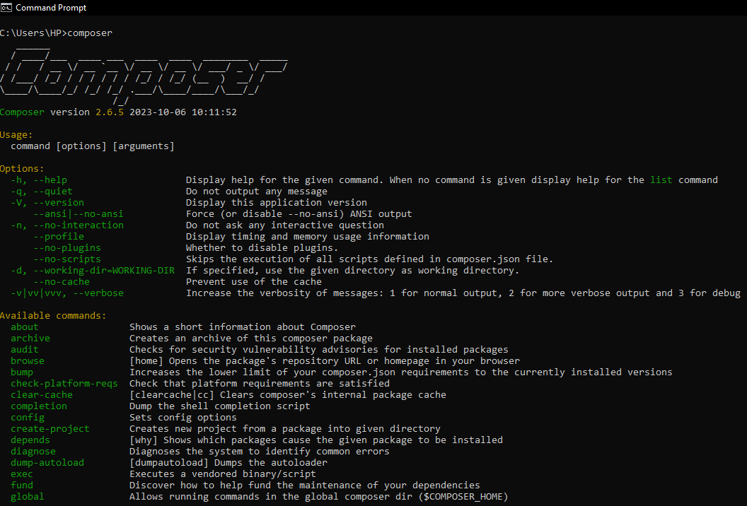

STEP 3: Go to cmd and follow following steps to install CodeIgniter 4 using composer:

C:\Users\HP>cd..

C:\Users>cd..

C:\>cd wamp64/www

C:\>cd wamp64/www>composer create-project codeigniter4/appstarter ci_project

Here ci_project is name of the project we have created.
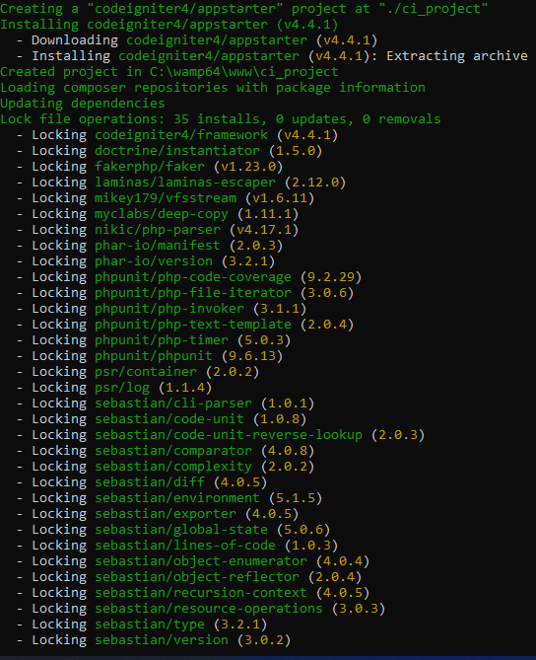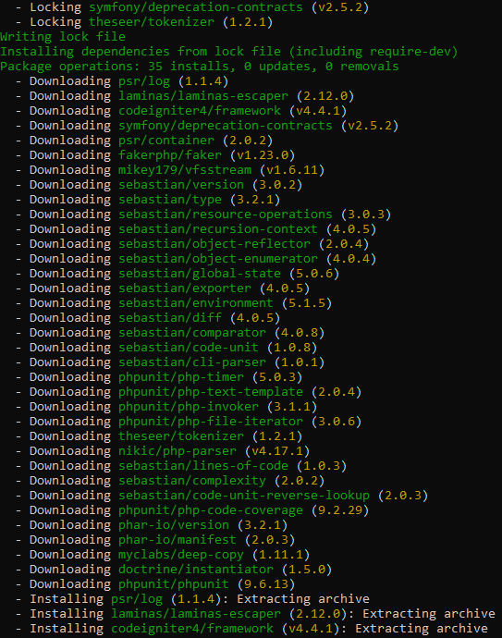
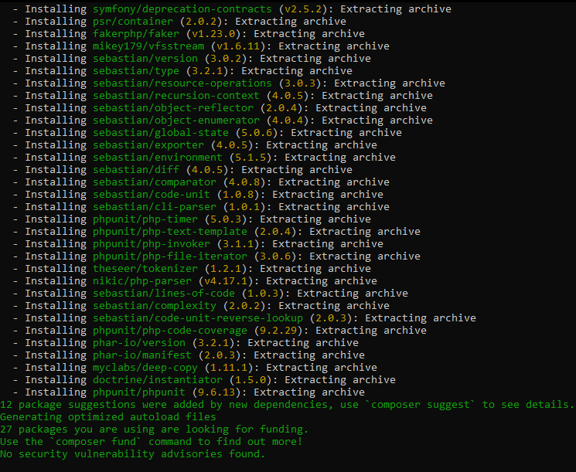
C:\wamp64\www>cd ci_project
C:\wamp64\www\ci_project>php spark serve
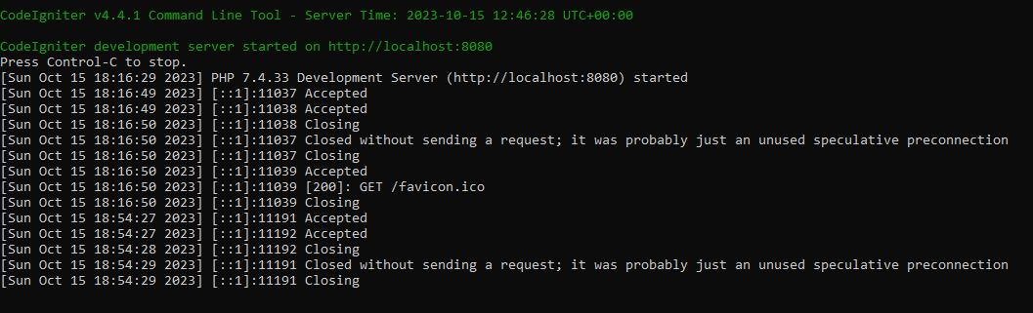

STEP 4: After final installation this page should be shown in “localhost:8080”.
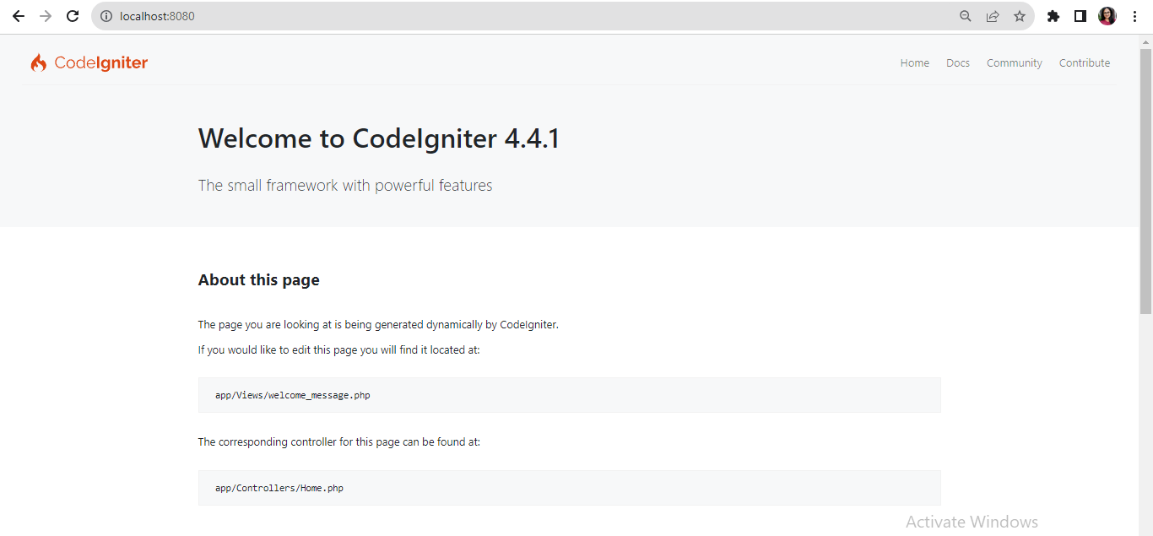
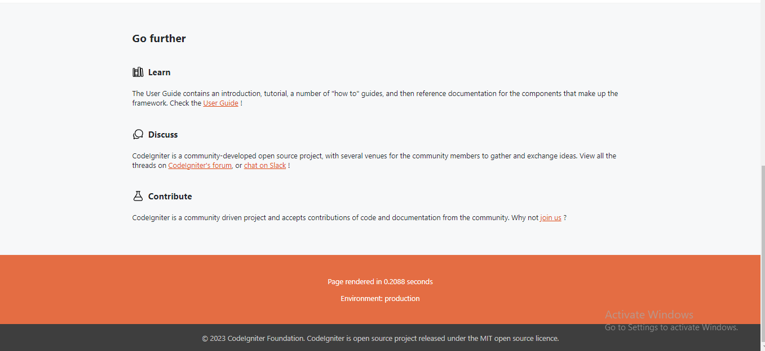

MVC (Model View Controller) Architecture:
The Model-View-Controller (MVC) framework is an architectural/design pattern that separates an application into three main logical components Model, View, and Controller. Each architectural component is built to handle specific development aspects of an application.
Features of MVC:
- It provides a clear separation of business logic, Ul logic, and input logic.
- It offers full control over your HTML and URLs which makes it easy to design web application architecture.
- It supports Test Driven Development (TDD).
Controller: The controller is the component that enables the interconnection between the views and model so it acts as an intermediary. It tells the model what to do. It processes all the business logic and incoming requests, manipulates data using the Model component, and interact with the View to render the final output.
View: It is used for all the UI logic of the application. It generates a user interface for the user. Views are created by the data which is collected by the model component but these data aren’t taken directly but through the controller. It only interacts with the controller.
Model: It corresponds to all the data-related logic that the user works with. This can represent either the data that is being transferred between the View and Controller components or any other business logic-related data. It can add or retrieve data from the database. It responds to the controller’s request because the controller can’t interact with the database by itself. The model interacts with the database and gives the required data back to the controller.

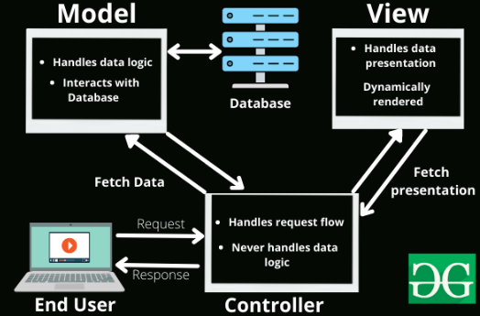

Flow to MVC Architecture:
- Send request
- Goes to controller
- Controller see which model to refer
- Goes from controller to model
- Return back information to controller
- Then it is shown on view

EXPERIMENT NO. 07: To construct a simple login page web application to authenticate users using CodeIgniter Framework and also perform CURD operations.
STEPS:

Step 1: Create Codeigniter Project
Step 2: Display Errors
Step 3: Generate Table into Database
Step 4: Connect CI to Database
Step 5: Create and Update User Model
Step 6: Register Auth Controllers
Step 7: Create Auth View
Step 8: Protect Route with Filter
Step 9: Run CI Application

CODE:
- FILE: app/Config/Boot/production.php
ini_set('display_errors', '1');
- FILE: Wamp Server
CREATE TABLE users (
id INT PRIMARY KEY AUTO_INCREMENT,
name VARCHAR(150),
email VARCHAR(150),
password VARCHAR(150),
created_at TIMESTAMP DEFAULT CURRENT_TIMESTAMP
) ENGINE=INNODB;

- FILE: app/Config/Database.php
public $default = [
'DSN' => '',
'hostname' => 'localhost',
'username' => 'root',
'password' => '',
'database' => 'codeigniter_db',
'DBDriver' => 'MySQLi',
'DBPrefix' => '',
'pConnect' => false,
'DBDebug' => (ENVIRONMENT !== 'development'),
'cacheOn' => false,
'cacheDir' => '',
'charset' => 'utf8',
'DBCollat' => 'utf8_general_ci',
'swapPre' => '',
'encrypt' => false,
'compress' => false,
'strictOn' => false,
'failover' => [],
'port' => 3306,
];

- FILE: app/Models/UserModel.php

<?php
namespace App\Models;
use CodeIgniter\Model;
class UserModel extends Model{
protected $table = 'users';
protected $allowedFields = [
'name',
'email',
'password',
'created_at'
];
}

- FILE: app/Controllers/SignupController.php

<?php
namespace App\Controllers;
use CodeIgniter\Controller;
use App\Models\UserModel;
class SignupController extends Controller
{
public function index()
{
helper(['form']);
$data = [];
echo view('signup', $data);
}
public function store()
{
helper(['form']);
$rules = [
'name' => 'required|min_length[2]|max_length[50]',
'email' => 'required|min_length[4]|max_length[100]|valid_email|is_unique[users.email]',
'password' => 'required|min_length[4]|max_length[50]',
'confirmpassword' => 'matches[password]'
];

if($this->validate($rules)){
$userModel = new UserModel();
$data = [
'name' => $this->request->getVar('name'),
'email' => $this->request->getVar('email'),
'password' => password_hash($this->request->getVar('password'), PASSWORD_DEFAULT)
];
$userModel->save($data);
return redirect()->to('/signin');
}else{
$data['validation'] = $this->validator;
echo view('signup', $data);
}
}
}

- FILE: app/Controllers/ProfileController.php

<?php
namespace App\Controllers;
use CodeIgniter\Controller;

class ProfileController extends Controller
{
public function index()
{
$session = session();
echo "Hello : ".$session->get('name');
}
}

- FILE: app/Controllers/SigninController.php

<?php
namespace App\Controllers;
use CodeIgniter\Controller;
use App\Models\UserModel;
class SigninController extends Controller
{
public function index()
{
helper(['form']);
echo view('signin');
}

public function loginAuth()
{
$session = session();
$userModel = new UserModel();
$email = $this->request->getVar('email');
$password = $this->request->getVar('password');

$data = $userModel->where('email', $email)->first();

if($data){
$pass = $data['password'];
$authenticatePassword = password_verify($password, $pass);
if($authenticatePassword){
$ses_data = [
'id' => $data['id'],
'name' => $data['name'],
'email' => $data['email'],
'isLoggedIn' => TRUE
];
$session->set($ses_data);
return redirect()->to('/profile');

}else{
$session->setFlashdata('msg', 'Password is incorrect.');
return redirect()->to('/signin');
}
}else{
$session->setFlashdata('msg', 'Email does not exist.');
return redirect()->to('/signin');
}
}
}

- FILE: app/View/signup.php
<!doctype html>
<html lang="en">
<head>
<meta charset="utf-8">
<meta name="viewport" content="width=device-width, initial-scale=1">
<link href="https://cdn.jsdelivr.net/npm/bootstrap@5.0.2/dist/css/bootstrap.min.css" rel="stylesheet">
<title>Codeigniter Auth User Registration Example</title>
</head>
<body>
<div class="container mt-5">
<div class="row justify-content-md-center">
<div class="col-5">
<h2>Register User</h2>
<?php if(isset($validation)):?>
<div class="alert alert-warning">
<?= $validation->listErrors() ?>
</div>
<?php endif;?>
<form action="<?php echo base_url(); ?>/SignupController/store" method="post">
<div class="form-group mb-3">
<input type="text" name="name" placeholder="Name" value="<?= set_value('name') ?>" class="form-control" >
</div>
<div class="form-group mb-3">
<input type="email" name="email" placeholder="Email" value="<?= set_value('email') ?>" class="form-control" >
</div>
<div class="form-group mb-3">
<input type="password" name="password" placeholder="Password" class="form-control" >
</div>
<div class="form-group mb-3">
<input type="password" name="confirmpassword" placeholder="Confirm Password" class="form-control" >
</div>
<div class="d-grid">
<button type="submit" class="btn btn-dark">Signup</button>
</div>
</form>
</div>
</div>
</div>
</body>
</html>

- FILE: app/View/signup.php
<!doctype html>
<html lang="en">
<head>
<meta charset="utf-8">
<meta name="viewport" content="width=device-width, initial-scale=1">
<link href="https://cdn.jsdelivr.net/npm/bootstrap@5.0.2/dist/css/bootstrap.min.css" rel="stylesheet">
<title>Codeigniter Auth User Registration Example</title>
</head>
<body>
<div class="container mt-5">
<div class="row justify-content-md-center">
<div class="col-5">
<h2>Register User</h2>
<?php if(isset($validation)):?>
<div class="alert alert-warning">
<?= $validation->listErrors() ?>
</div>
<?php endif;?>
<form action="<?php echo base_url(); ?>/SignupController/store" method="post">
<div class="form-group mb-3">
<input type="text" name="name" placeholder="Name" value="<?= set_value('name') ?>" class="form-control" >
</div>
<div class="form-group mb-3">
<input type="email" name="email" placeholder="Email" value="<?= set_value('email') ?>" class="form-control" >
</div>
<div class="form-group mb-3">
<input type="password" name="password" placeholder="Password" class="form-control" >
</div>
<div class="form-group mb-3">
<input type="password" name="confirmpassword" placeholder="Confirm Password" class="form-control" >
</div>
<div class="d-grid">
<button type="submit" class="btn btn-dark">Signup</button>
</div>
</form>
</div>
</div>
</div>
</body>
</html>

- FILE: app/View/signin.php
<!doctype html>
<html lang="en">
<head>
<meta charset="utf-8">
<meta name="viewport" content="width=device-width, initial-scale=1">
<link href="https://cdn.jsdelivr.net/npm/bootstrap@5.0.2/dist/css/bootstrap.min.css" rel="stylesheet">
<title>Codeigniter Login with Email/Password Example</title>
</head>
<body>
<div class="container">
<div class="row justify-content-md-center">
<div class="col-5">

<h2>Login in</h2>

<?php if(session()->getFlashdata('msg')):?>
<div class="alert alert-warning">
<?= session()->getFlashdata('msg') ?>
</div>
<?php endif;?>
<form action="<?php echo base_url(); ?>/SigninController/loginAuth" method="post">
<div class="form-group mb-3">
<input type="email" name="email" placeholder="Email" value="<?= set_value('email') ?>" class="form-control" >
</div>
<div class="form-group mb-3">
<input type="password" name="password" placeholder="Password" class="form-control" >
</div>

<div class="d-grid">
<button type="submit" class="btn btn-success">Signin</button>
</div>
</form>
</div>

</div>
</div>
</body>
</html>

- FILE: app/Config/Filters.php

/*** Configures aliases for Filter classes to
* make reading things nicer and simpler.**/
public $aliases = [
'csrf' => \CodeIgniter\Filters\CSRF::class,
'toolbar' => \CodeIgniter\Filters\DebugToolbar::class,
'honeypot' => \CodeIgniter\Filters\Honeypot::class,
'authGuard' => \App\Filters\AuthGuard::class,
];

FILE: app/Filters/AuthGuard.php

<?php
namespace App\Filters;
use CodeIgniter\HTTP\RequestInterface;
use CodeIgniter\HTTP\ResponseInterface;
use CodeIgniter\Filters\FilterInterface;

class AuthGuard implements FilterInterface
{
public function before(RequestInterface $request, $arguments = null)
{
if (!session()->get('isLoggedIn'))
{
return redirect()
->to('/signin');
}
}

public function after(RequestInterface $request, ResponseInterface $response, $arguments = null)
{

}
}

- FILE: app/Config/Routes.php

$routes->get('/', 'SignupController::index');
$routes->get('/signup', 'SignupController::index');
$routes->match(['get', 'post'], 'SignupController/store', 'SignupController::store');
$routes->match(['get', 'post'], 'SigninController/loginAuth', 'SigninController::loginAuth');
$routes->get('/signin', 'SigninController::index');
$routes->get('/profile', 'ProfileController::index',['filter' => 'authGuard']);
Comment out following route
// $routes->get('/', 'Home::index');

OUTPUT

Registration

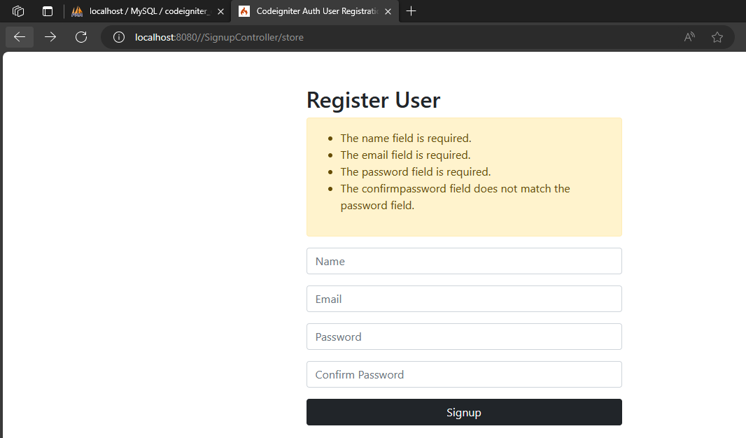

Login

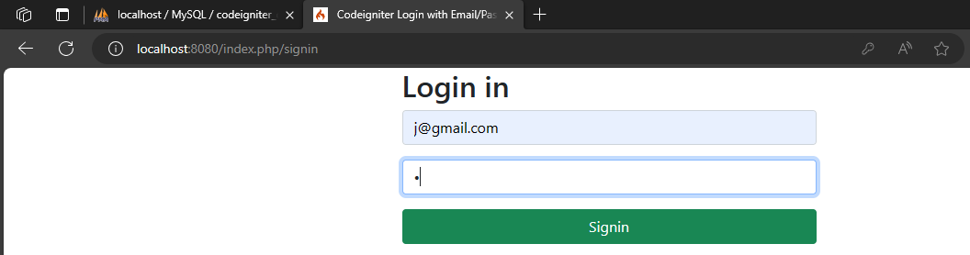
Dashboard

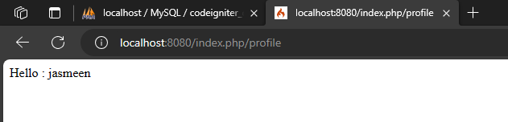

Database in Wamp64 server

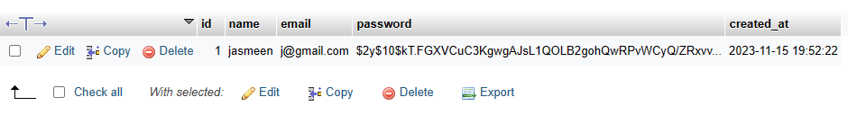

EXPERIMENT NO. 08: To install and setup, configure the Laravel Framework.
STEP 1: Must install Wamp64 server.
STEP 2: Must install composer.
STEP 3: Create a folder and inside folder create another folder
PS D:\Laravel_Jeenu\first-app>
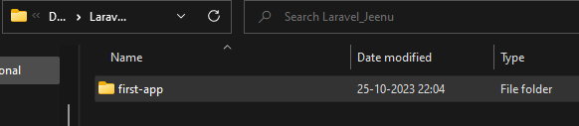
STEP 4: Run this command to install laravel:
PS D:\Laravel_Jeenu\first-app> composer global require laravel/installer
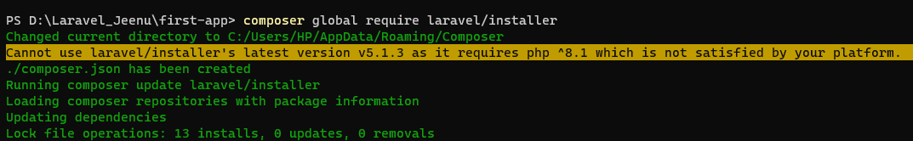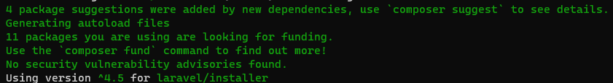
STEP 5: Run this command to create new demo-app in laravel:
PS D:\Laravel_Jeenu\first-app> laravel new demo-app
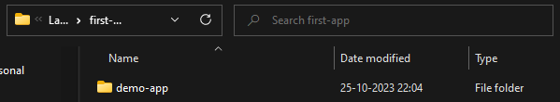
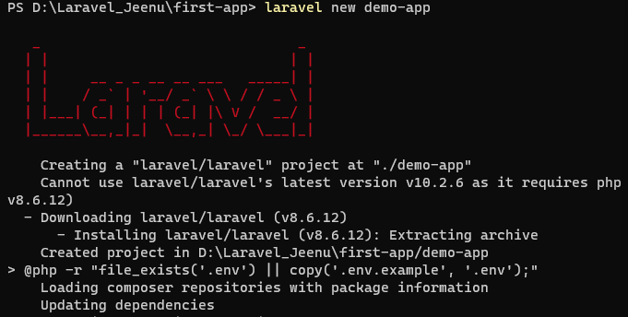

STEP 6: Go to demo-app folder
PS D:\Laravel_Jeenu\first-app> cd demo-app

STEP 7: Run following command to run php on local machine.
PS D:\Laravel_Jeenu\first-app\demo-app> php artisan serve
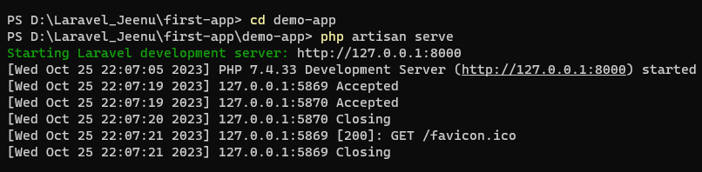

STEP 8: Now at this http://127.0.0.1:8000 development server is started. Following page must be shown to ensure that laravel is installed successfully.
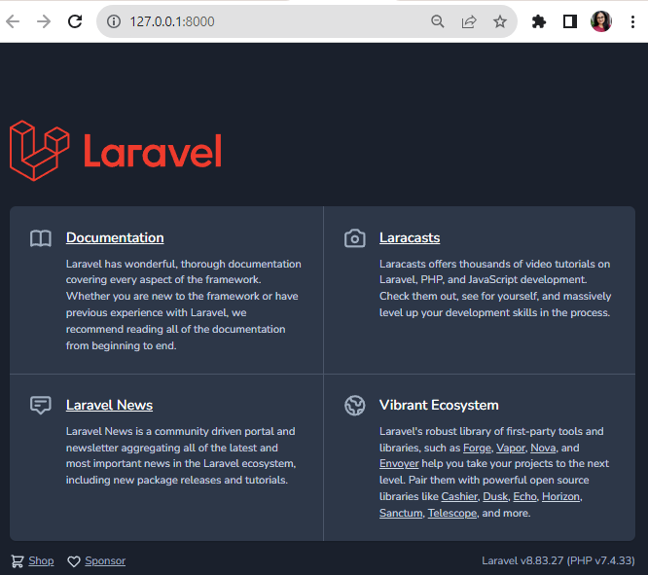

EXPERIMENT NO. 09: To construct any simple web application using Laravel Framework.
Step 1: Install Laravel

Step 2: Update DB Credentials
Now go the .env and change the DB_DATABASE, DB_USERNAME, DB_PORT and DB_PASSWORD according to your database details.
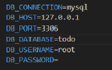

Step 3: Migrate Database
Laravel migration is one of the laravel’s popular feature which let us create, modify and delete tables and its columns.Laravel ships some of the migration files for some tables by default which includes users, password resets, failed_jobs and personal_access_tokens and migrations tables. And you can see them by going to database/migrations folder:
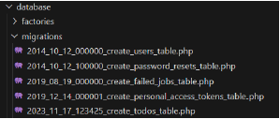
So now in order to convert that migration files to tables in the database, we run to migrate by using the following command in the terminal:
And if you open the database you will see that your database will now have 6 tables which I have mentioned above:
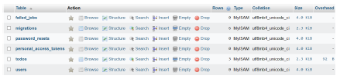

Step 4: Run Application
Now in order to start application, you need to type following command in the terminal:
This will create a new migration file in the database/migrations folder with the name of create_todos_table.php with some date prefix which will contains some following code:
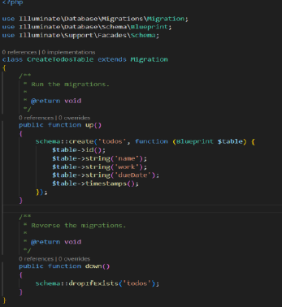

Step 6: Create Model for the todos table
Model in laravel is a way of querying data to and from the table within the database.
Since we want to create model for our todos table, we will create that by using following command:
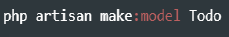
Setting up the model:
If you open that up, you will see something like this:
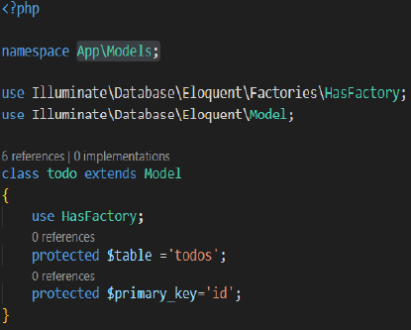
Step 7: Create Controller and Route
What is a Controller in laravel?
A Controller controls the behavior of the request. It accepts request coming from the route and satisfy them.In the controller, we usually write all of our business logic. Usually, we validate the request and then fetching data from the database using model.
In order to create controller for our Todo Model or todos table, you need to type the following command:
In order to create the route as the resource, go to routes/web.php file and at the end of the file write:
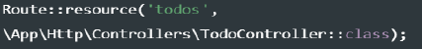

Step 8: Create View File
The view usually contains all the frontend of the application aka HTML.
Laravel framework provides out of the box blade templating engine that’s helps to write HTML, PHP code easy to write plus provides tons of features.
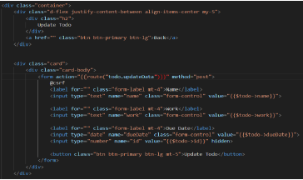

Step 9: Run Application
Now in order to start application, you need to type following command in the terminal:

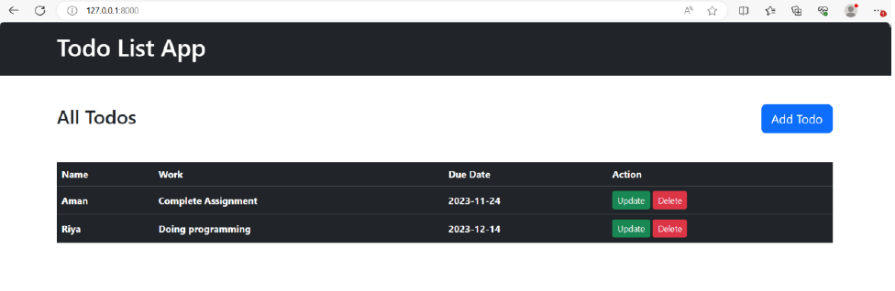
Add Todo:
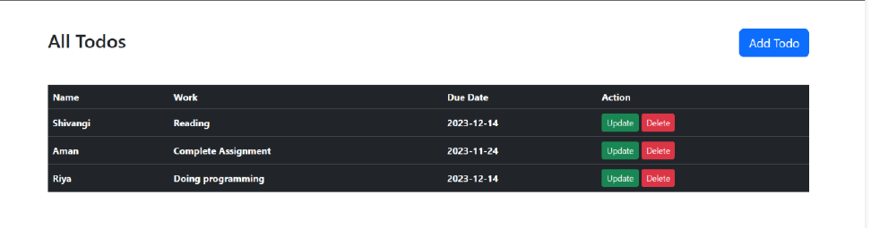
Update Todo:
Delete an Item:

